Lesson 04 Demo 05

Creating Scale Sets

Objective: To create virtual machine scale set to distribute workload from VMs

Tools required: None

Prerequisites: None

Steps to be followed:
- Create a virtual machine scale set from the portal

Step 1: Create a virtual machine scale set from the portal

  - Sign in to the Azure portal as an administrator

1.2 Click on + Create a resource

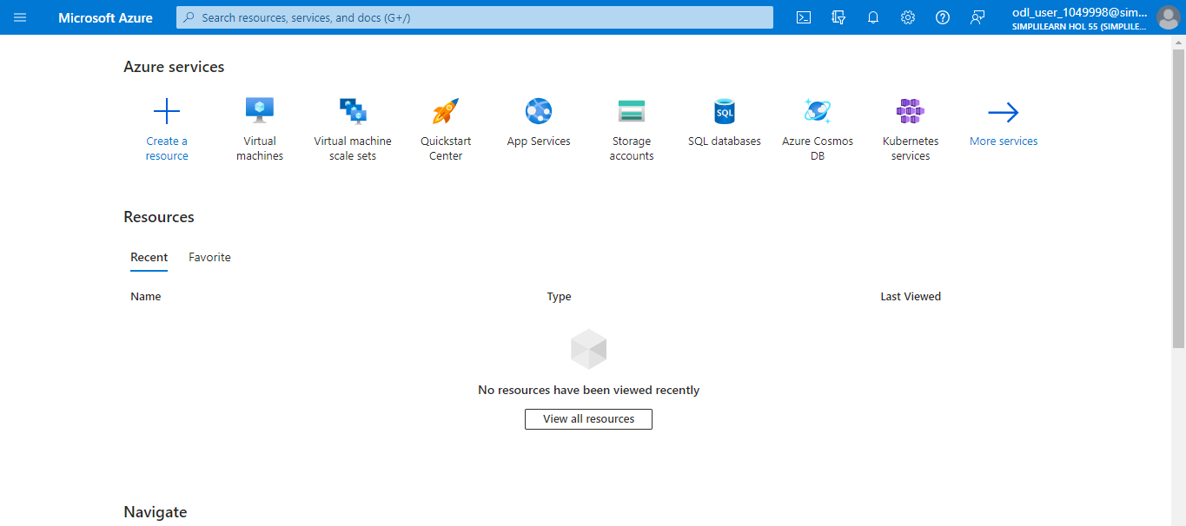

1.3 Search and select Virtual machine scale set

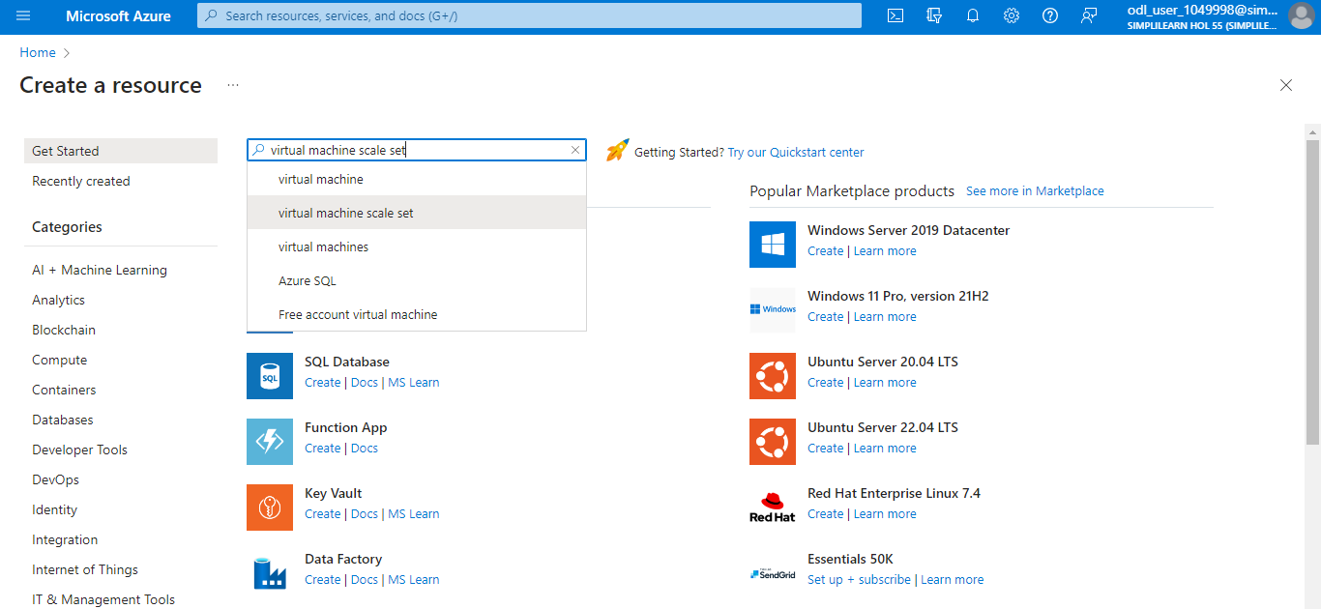

1.4 Click on Create

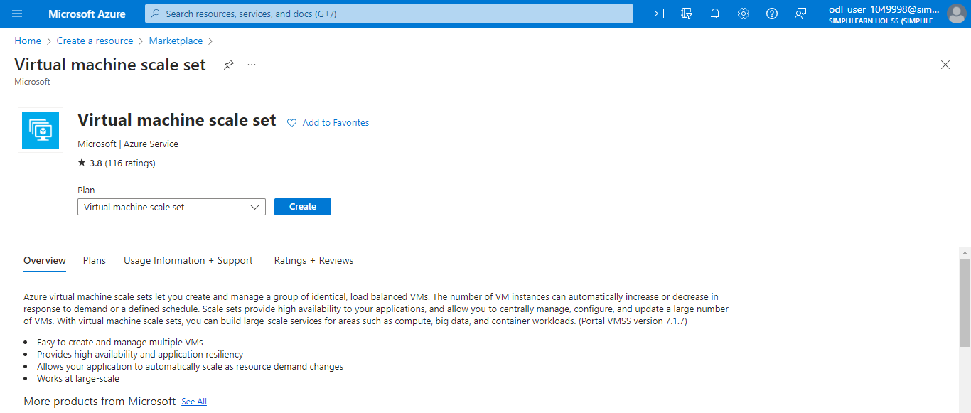

1.5 Under Project details, make sure the correct subscription is selected, and then
choose Create new in the resource group. Type myResourceGroup1 for the name.

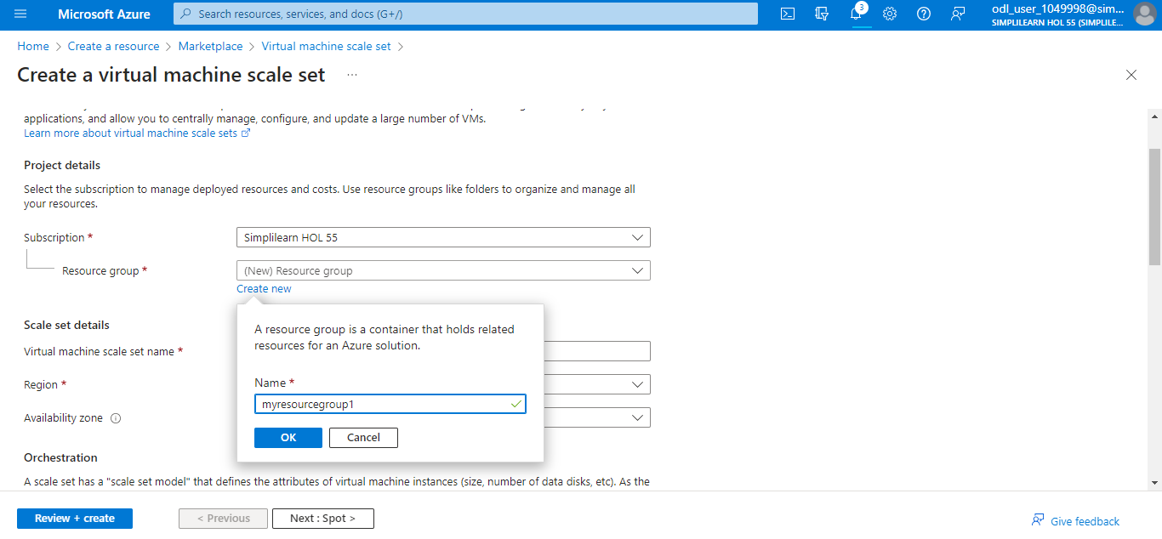

1.6 Enter the Virtual machine scale set name as scaleset1 and choose Windows Server
2022 Datacenter - Gen2 for the Image. Leave the other fields as default.

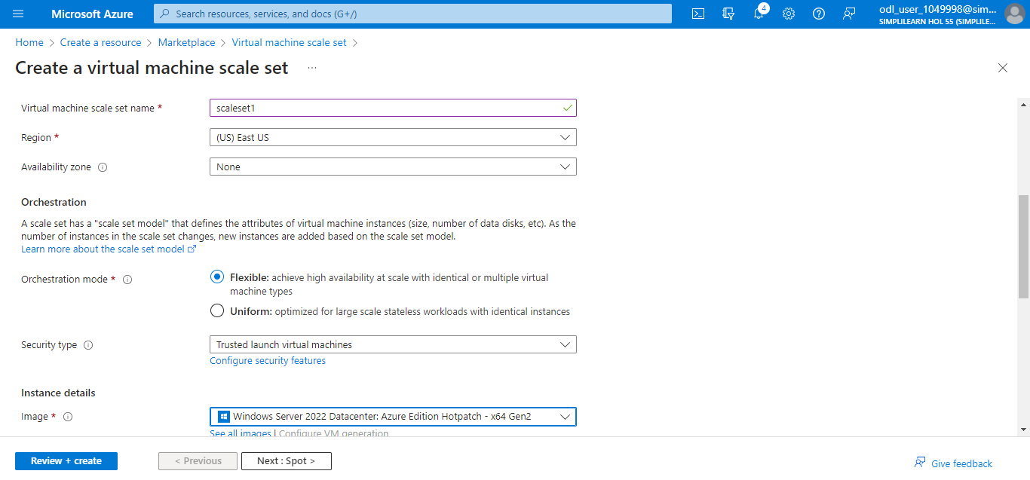

1.7 Under the Administrator account, provide a Username, such as azureuser, and a Password. The password must be at least 12 characters long and meet the complexity requirements. Leave the rest field as default and select Review + create.

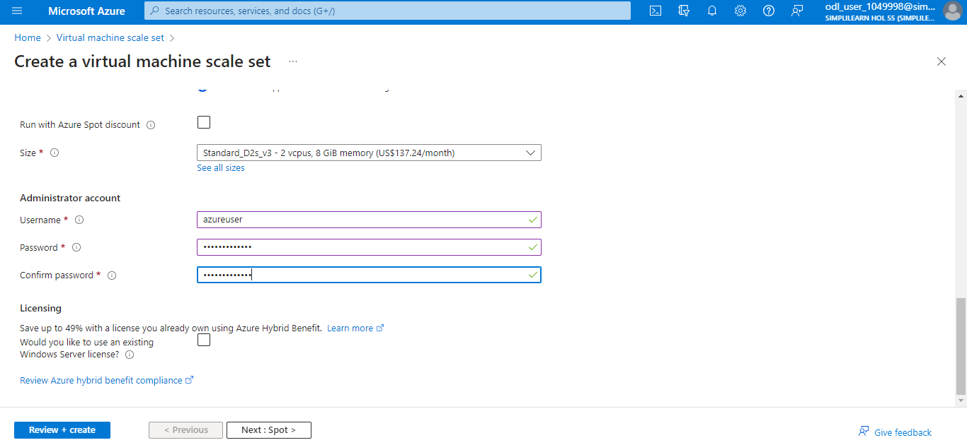

1.8 Once validation is successful, select the Create button at the bottom of the page

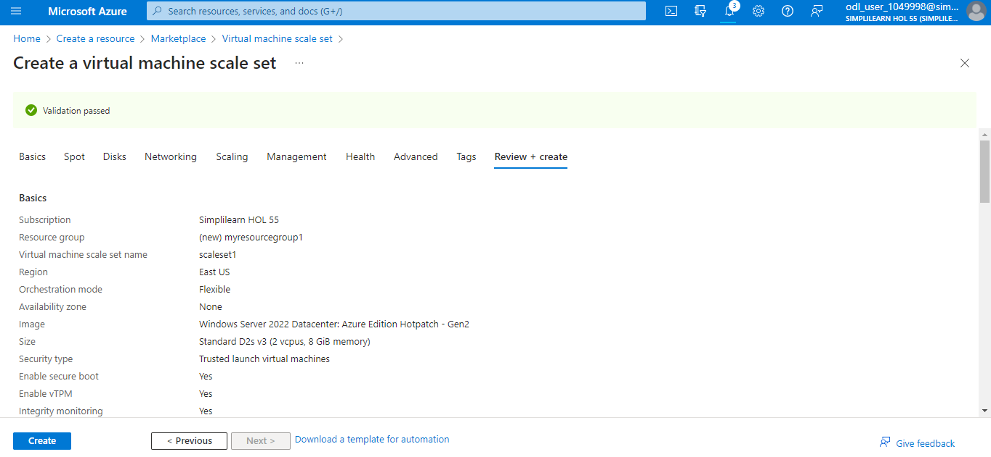

1.9 After deployment is complete, select Go to resource

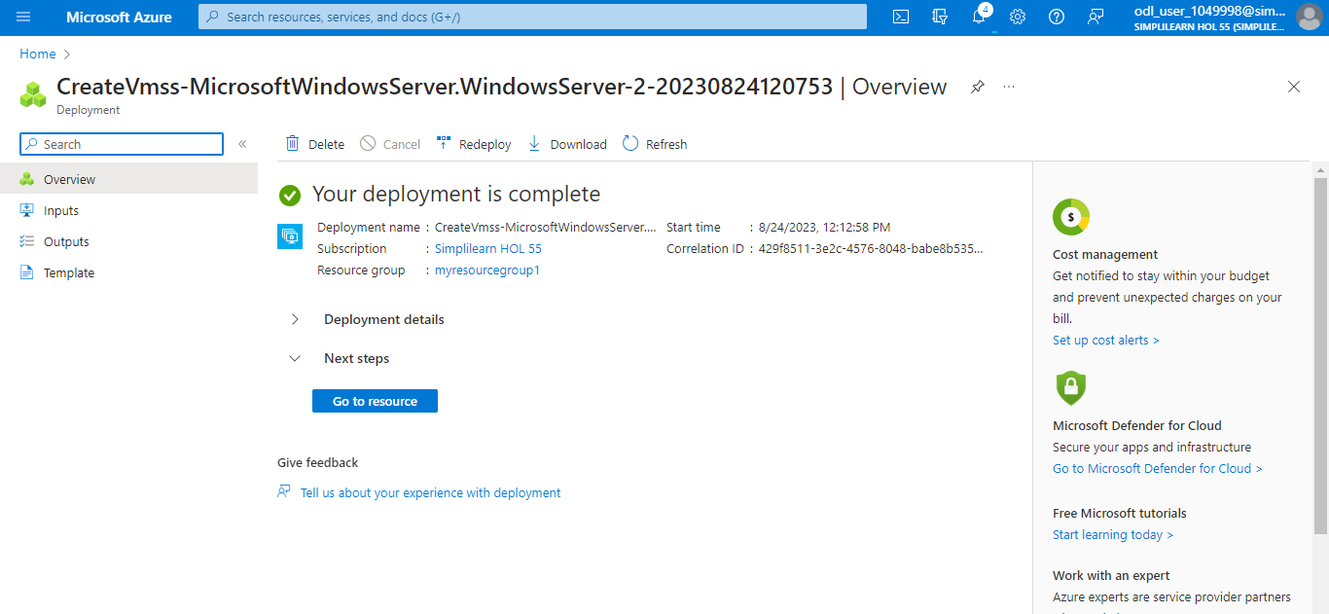

You have now successfully created a virtual machine scale set to distribute workload to multiple virtual machine instances.

